Project Development - Database design

## Hospital Management System

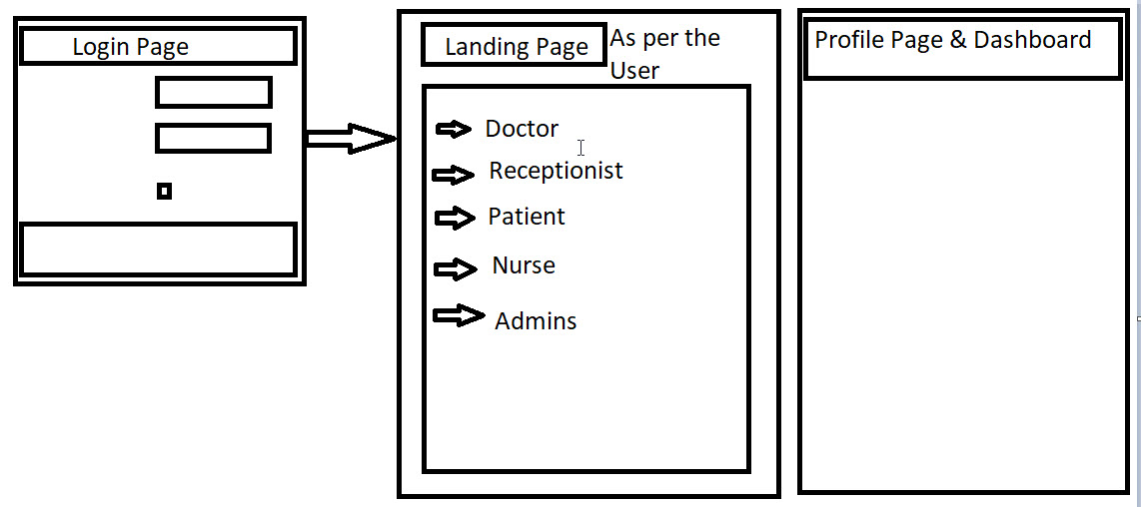

No of Pages for each users :

1. Login page
2. Doctor pages - 3 - Profile updation, Dashboard : Present, past, Future worklog and cafeteria, Attendance updation
3. Reception user: 3- Profile updation, Dashboard : Present, past, Future financial and patient’s data and cafeteria data, Attendance updation
4. Patients - 1 page
5. Nurse - 3 - Profile updation, Dashboard : Present, past, Future worklog and cafeteria, Attendance updation
6. Admins- 2 pages : Reports & Profile

Application Functionalities:

1. Admin

2. User

3. Doctor / Supervisor

Administrator :-

1. No of Users
2. No of Doctors
3. Collections: In Hand cash
4. Add New Doctor / Delete the Doctor
5. Reports - Financial
6. Reports - General
7. Daily In and Out Patient List
8. Add new Users / Delete the Users

User:

1. Registration to the website
2. Login to the website
3. Appointment
4. Pay the Fee online
5. Reports
6. Feedback

Doctor:

1. Login
2. Check the appointments
3. Generate the reports
4. Advice medications

**Data flow diagram for the User Module**

